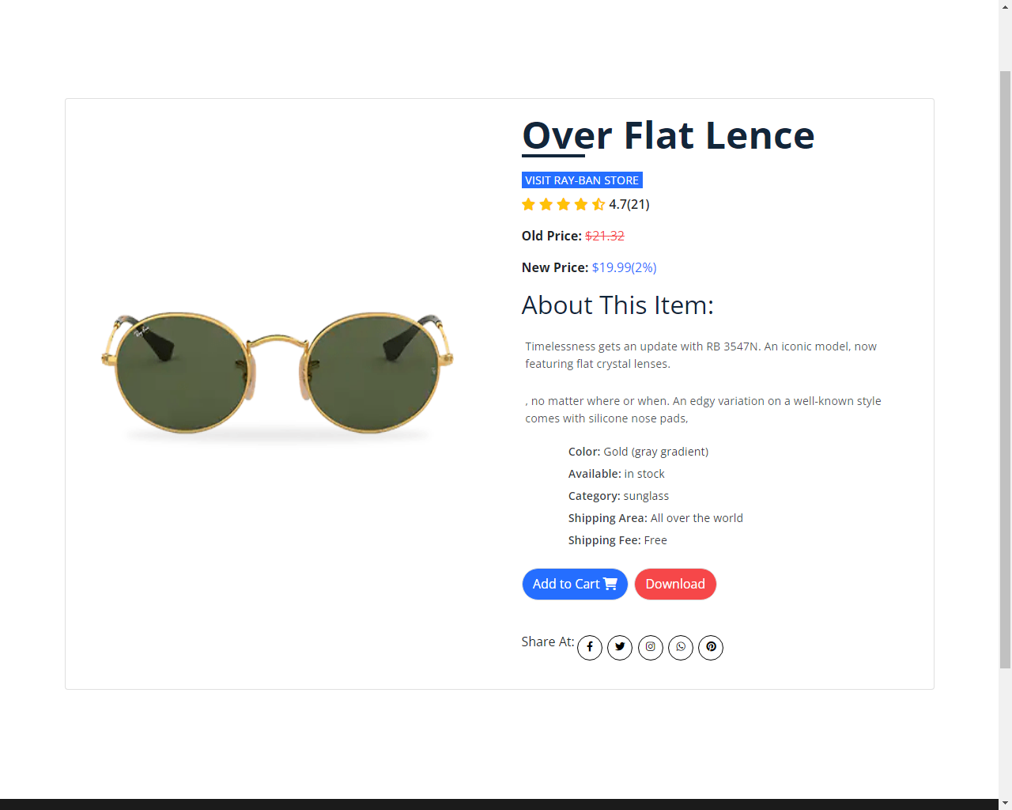

Timelessness gets an update with RB 3547N. An iconic model, now featuring flat crystal lenses. The evolution of round has met flat crystal and has been given an unmistakable Ray-Ban feeling, while keeping the essence of round. The unique flash lenses come in a variety of colors, so you can really shine, no matter where or when. An edgy variation on a well-known style comes with silicone nose pads, which ensure a comfortable fit and amazing comfort, RB 3547N a quintessential part of any wardrobe.

**Product Details**